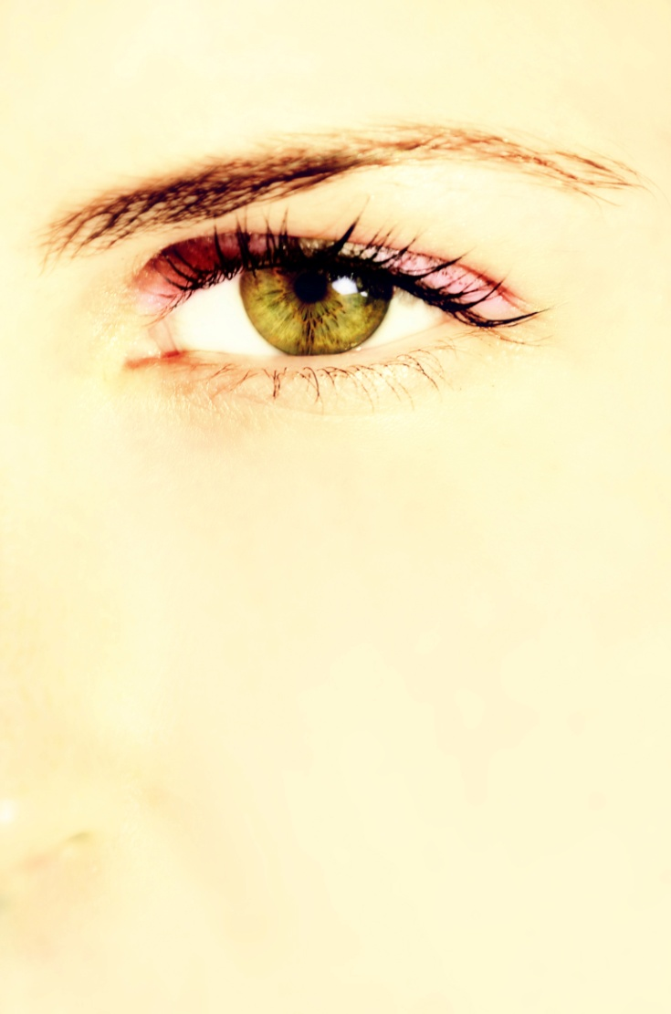

Nature is an absolutely beautiful thing, and complexities of the human body get lost as a whole. By taking this macro of the model's eye the detail is a real eye catcher. The softness of the skin and lack of any real facial features or imperfections really pulls your attention to the eye. The reflection off of the lens almost brings in an element of beauty onto an already stunning iris. The variations in color and texture really make an interesting level of detail that wouldn't normally be visible in a full body portrait unless it was extremely enhanced. This image captures the true beauty of the human eye perfectly.